Alice in Wonderland, Lesson 1 ‘Enter Wonderland’ HAVO/VWO
- Read the text ‘Alice in Wonderland, Chapter 1’ and write down 20 difficult words with their translation.
English | Dutch | English | Dutch

- Watch the video of Alice falling and if necessary, read the chapter again.
https://www.youtube.com/watch?v=8xLpaQFjSio

- Name 3 things Alice sees on her way down the rabbit- hole.
-
-
-
- Name 4 differences between Alice’s fall in the film and in the book.
-
-
-
-
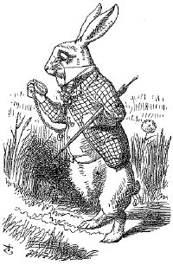
- Give a description of the Drink Me-drink or the Eat Me-cake. What does it look like and how exactly does it work? Is it dangerous and, if yes, what happens if you take too much?
Drink Me-drink:
Eat Me-cake:
- What kind of girl do you think Alice is? Is she smart, dumb, curious, rude, friendly or…? And why? Give a thorough explanation of your answer.
- I think Alice is

- You have brainstormed about what wonderland is. You have read and seen how Alice gets there… Now imagine your very own Wonderland…

Write a short text about your own Wonderland. Make sure you use the following points in your text. Use between 200 and 250 words.
- How do you get there?
- What does it look like?
- What can you do there?
- Name three types of animals you can find there.

